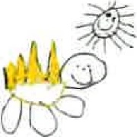
General Welfare Requirement: Suitable premises, environment and equipment
Outdoor and indoor spaces, furniture and toys must be safe and suitable for their purpose.

Gorran Pre School
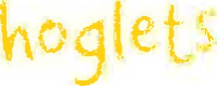
Health and safety
3.2 Health and safety general standards
Policy statement
At Gorran Pre-School Hoglets we believe that the health and safety of children is of paramount importance. We make our setting a safe and healthy place for children, parents, staff and volunteers.
- We aim to make children, parents and staff aware of health and safety issues and to minimise the hazards and risks to enable the children to thrive in a healthy and safe environment.
Our member of staff responsible for health and safety are:
Michelle Beard
- They are competent to carry out these responsibilities.
- They have undertaken health and safety training and regularly update their knowledge and understanding.
We display the necessary health and safety poster in
The Preschool Foyer

Insurance cover
We have public liability insurance and employers' liability insurance. The certificate for public liability insurance is displayed:
On the notice board opposite the door in the foyer.
EYFS key themes and commitments
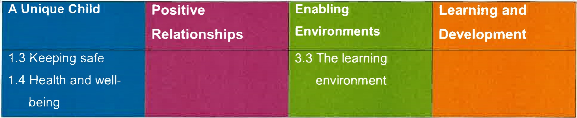
Procedures

Awareness raising
- Our induction training for staff and volunteers includes a clear explanation of health and safety issues so that all adults are able to adhere to our policy and procedures as they understand their shared responsibility for health and safety. The induction training covers matters of employee well-being, including safe lifting and the storage of potentially dangerous substances.
- Records are kept of these induction training sessions and new staff and volunteers are asked to sign the records to confirm that they have taken part.
Health and safety issues are explained to the parents of new children so that they understand the part played by these issues in the daily life of the setting.
As necessary, health and safety training is included in the annual training plans of staff, and health and safety is discussed regularly at staff meetings.
We operate a no smoking policy.
- Children are made aware of health and safety issues through discussions, planned activities and routines.

Safety of adults
- Adults are provided with guidance about the safe storage, movement, lifting and erection of large pieces of equipment.
- When adults need to reach up to store equipment or to change light bulbs they are provided with safe equipment to do so.
- All warning signs are clear and in appropriate languages.
Adults do not remain in the building on their own or leave on their own after dark.
- The sickness of staff and their involvement in accidents is recorded. The records are reviewed termly to identify any issues that need to be addressed.
We keep a record of all substances that may be hazardous to health - such as cleaning chemicals, or gardening chemicals if used. This states what the risks are and what to do if they have contact with eyes or skin or are ingested. It also states where they are stored.
We keep all cleaning chemicals in their original containers.
Windows
Low level windows are made from materials that prevent accidental breakage or are made safe.
Windows are protected from accidental breakage or vandalism from people outside the building.
Windows above the ground floor are secured so that children cannot climb through them.
Doors
We take precautions to prevent children's fingers from being trapped in doors
FloorS
All floor surfaces are checked daily to ensure they are clean and not uneven, wet or damaged
Electrical/gas equipment
All electrical/gas equipment conforms to safety requirements and is checked regularly. Our boiler/electrical switch gear/meter cupboard is not accessible to the children.
Fires, heaters, electric sockets, wires and leads are properly guarded and the children are taught not to touch them.
Storage heaters are checked daily to make sure they are not covered.
There are sufficient sockets to prevent overloading.
The temperature of hot water is controlled to prevent scalds.
Lighting and ventilation is adequate in all areas including storage areas.

Storage
All resources and materials from which children select are stored safely.
All equipment and resources are stored or stacked safely to prevent them accidentally falling or collapsing.
Outdoor area
Our outdoor area is securely fenced.
Our outdoor area is checked for safety and cleared of rubbish before it is used.
- Adults and children are alerted to the dangers of poisonous plants, herbicides and pesticides
- The school pool is securely covered or otherwise guarded.
- Where water can fom a pool on equipment, it is emptied before children start playing outside.
Our outdoor sand pit is covered when not in use and is cleaned regularly.
- All outdoor activities are supervised at all times.
Hygiene
We regularly seek information from the Environmental Health Department and the Health
Authority to ensure that we keep up-to-date with the latest recommendations.
Our daily routines encourage the children to learn about personal hygiene.
We have a daily cleaning routine for the setting which includes play room(s), kitchen, rest area, toilets and nappy changing areas.
- We have a schedule for cleaning resources and equipment, dressing-up clothes and furnishings.
The toilet area has a high standard of hygiene including hand washing and drying facilities and the disposal of nappies.
We implement good hygiene practices by:
cleaning tables beueen activities; cleaning toilets regularly; wearing protective clothing - such as aprons and disposable gloves - as appropriate; providing sets of clean clothes; providing tissues and wipes; and ensuring individual use of flannels and towels.

Activities and resources
- Before purchase or loan, equipment and resources are checked to ensure that they are safe for the ages and stages of the children currently attending the setting.
- The layout of play equipment allows adults and children to move safely and freely between activities.
All equipment is regularly checked for cleanliness and safety and any dangerous items are repaired or discarded.
All materials, including paint and glue, are non-toxic.
Sand is clean and suitable for children's play.
- Physical play is constantly supervised.
- Children are taught to handle and store tools safely.
Children learn about health, safety and personal hygiene through the activities we provide and the routines we follow.
Any faulty equipment is removed from use and is repaired. If it cannot be repaired it is discarded.
Large pieces of equipment are discarded only with the consent of the manager and the chairperson or owner
Legal Framework
- Health and Safety at Work Act (1974)
- Management of Health and Safety at Work Regulations 1992
- Electricity at Work Regulations 1989
- Control of Substances Hazardous to Health Regulations(COSHH)
(2002)
- Manual Handling Operations Regulations 1992 (as amended)
Health and Safety (Display Screen Equipment) Regulations 1992
This policy was adopted at a meeting of Gorran Preschool
Held on: October 2019

Date to be reviewed October 2020

Name of signatory
Manger:

